

|  |  |
| --- | --- |
| **Web technologies | Front-End** | |
| Students’ names: | Nurrasyl Berik,Zhansaya Kuanshpek |
| Teacher name: | Dariya Bissengaliyeva |
| Project name: | Destruction |
| Project type: | Group |

**INTRODUCTION**

After negotiations, our team combined all the ideas and made a common one. So we decided to create a server of Minecraft, related to the fact that we both play Minecraft and our interests coincided here. We planned to make a server that includes all the information you can register, contact the creators, and the system of donation. With our site, anyone can register and play on the server, he will be able to immerse themselves in a virtual world with pleasure. According to the idea of the site, participants will be able to play with their friends or can find friends (friends) with us and survive together fighting with other players. At the end of the guests waiting for the worst mystery of the Pentagon according to our group. And our main goal is to create a good server for players.

**MAIN PART (Practical)**

Zhansaya was responsible for the design and writing the codes and Nurasyl was responsible for writing the codes and for the creation of the site.

intro_title, first page of index.html:

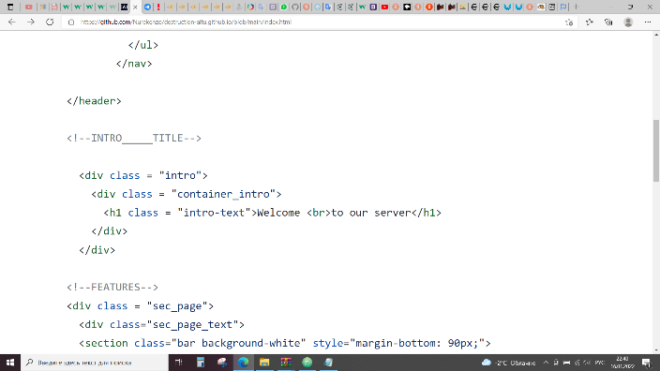

features title:

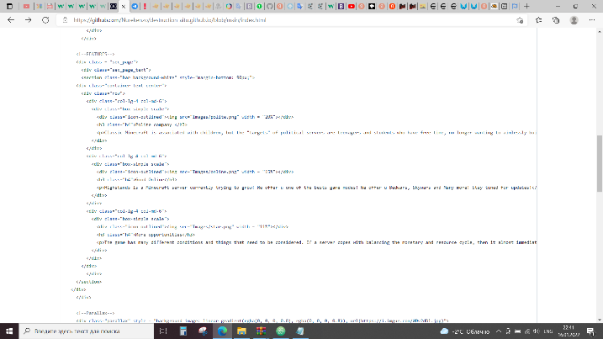

Parallax and some info:

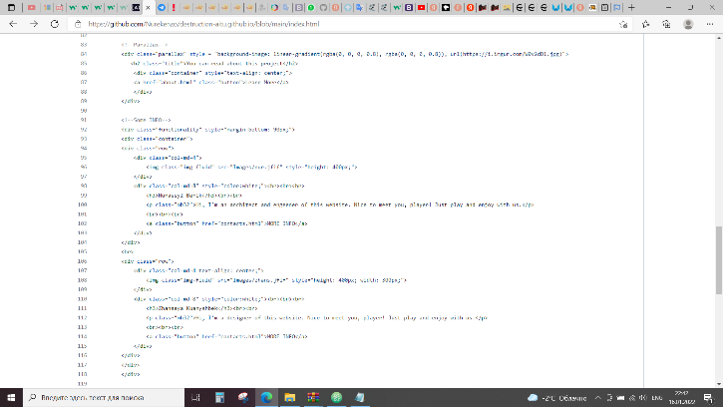

Carousel:

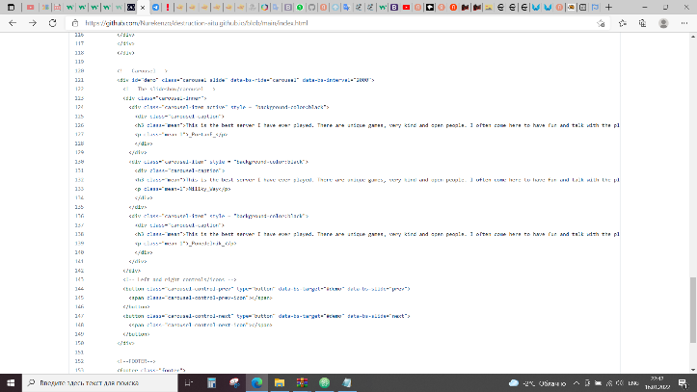

Footer:

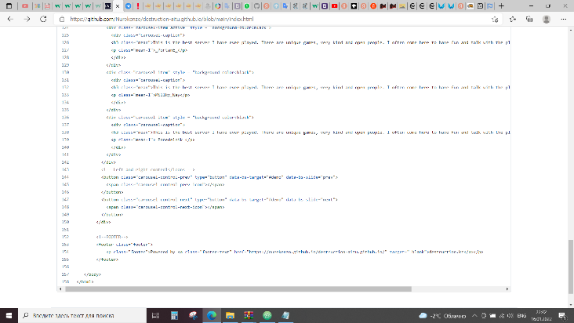

Adding new html pages.

New css files and images:

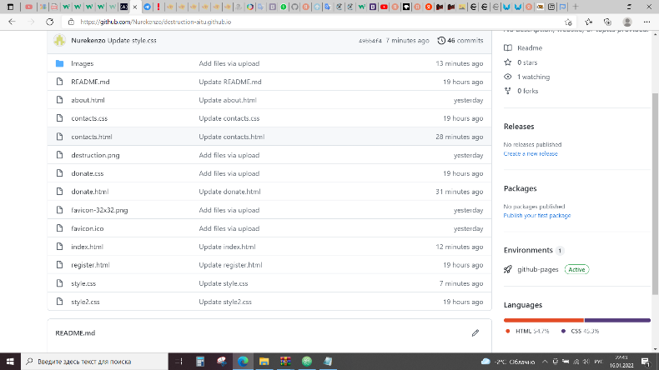

**PROGRESS [optional]**

|  |  |
| --- | --- |
| 20.12.2021 | The first thing we did was assemble a team and decide on a course of action. Furthermore, we listened to each team member's thoughts and integrated them into one. |
| 22.12.2021 | First, we learned about how to create a website and what it takes to do it. We had to learn about languages for web development. We watched the lectures and started doing practical assignments. Also we decided approximately what will be the design of the site and began to create. |
| 25.12.2021 | On the YouTube platform, we studied the video tutorials necessary for us.  After we understood how websites are created, we came up with the idea of our project and proceeded to perform a practical task. |
| 27.12.2021 | Watched the lectures, completed the tasks of the second week. In addition, we decided on the design of the project. |
| 30.12.2021 | Having written the initial code, tested it, we began to think of a scenario for the story of our site, and, accordingly, what will include our site . |
| 04.01.2022 | In the third week, we watched the lectures, completed the practice, and proceeded to the layout of the site itself in css. We compared our site with other similar ones, and brought out the shortcomings. Fixed them. |
| 12.01.2022 | We reviewed the lectures and practical tasks of the fourth week. Added a couple of details to our site. Showed to friends, and gave for testing. |
| 14.01.2022 | After asking the opinions of people who tested the site, they came to the conclusion that everyone liked it. The site works great and performs all functions. It remains only to correct this in our report, and the deed is done. |
| 16.01.2022 | We wrote a report to our website. |